“The Middle East at the Strategic Crossroads - Converging and Diverging Interests within Asia”

Workshop Report

Submitted by the Shanghai Institutes for International Studies and the Near East South Asia Center for Strategic Studies

May 2015

Course Director: Professor Brianne Todd
Program Planner: Marlene Ryan
Participant Programs: Brooke Sigler

INDEX

Seminar Report
Seminar Schedule
Editors: Mr. Jeffrey Payne, NESA and Dr. Jin Liangxiang, SIIS

With Special Thanks to all Participants
and
Dr. Chen Dongxiao, President of SIIS
Lt. Gen Terry Wolff, Director of NES

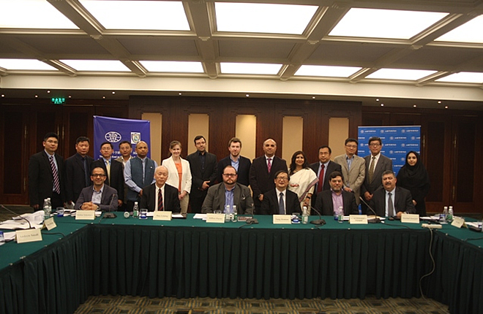
- Seminar Report: The Middle East at the Strategic Crossroads

Overview: From 5-7 May, Shanghai Institutes for International Studies (SIIS) and the Near East South Asia (NESA) Center for Strategic Studies jointly conducted a workshop focusing on West Asia. The participants included a delegation from SIIS, NESA, China, the United States, Iran, the United Kingdom, Jordan, Turkey, and India. The workshop focused on the current security situation throughout the Levant and Gulf regions, as well as considerations for future strategic development and opportunities for multilateral cooperation. The workshop featured some intense debates among participants as everyone navigated some difficult topics. Participants uniformly agreed that the workshop represented a strong first step in working towards avenues of mutual cooperation.
Issues of Importance within the Middle East:
Based on conversations held during the workshop, the following issues (ranked in no particular order) were continually brought up in relation to them being of importance for both regional and non-regional actors.
- How US policy towards the Middle East and the positioning of its resources within the Middle East will impact the stability of the larger region remains a central question. Perceptions regarding the United States and its footprint in the Middle East vary – with some seeing the United States as a declining power that is slowly removing its assets from the region to others viewing the United States as the key country operating in the region in regards to stability (it should also be noted that both views are not necessarily mutually exclusive). Discussion revealed that the United States needs to revise how it communicates to the region.
- How China’s vision for its role in the Middle East will evolve, both in relation to and independent of the Belt and Road Initiative, is an increasingly important aspect of the contemporary Middle East. China has enhanced its economic engagement throughout the region, with the Persian Gulf States being of particular interest. Plans have been developed to connect China with the Middle East through roadways, sea lanes, railways, and pipelines. A greater economic role for China will certainly contribute in determining the future trajectory of the region as a whole. It is also expected that China’s contribution in politics, peace, and security will occur.
It is clear from discussion that there is no question that China’s footprint will deepen in the Middle East. The real question of importance is how China will deepen its engagement. Some participants questioned how China will secure its greater investment in the Middle East, while others argued that China’s push west is geo-economic in function and does not undercut the interests of other states, namely the United States. Many agreed that China’s vision for the Middle East counters the claim that China is a free rider.
- India is a rising economic power in Asia that sees the Middle East as part of its extended neighborhood. These ties reflect that India looks to enhance ways to engage with the states of the Middle East. The Indian diaspora in the Middle East numbers approximately 7 million, or 35 percent of the total diaspora population. That population accounts for nearly 40 billion USD in remittances to India. Additionally, the Indian government sees the Middle East as essential for both its energy security and the health of its industrial sectors. From a strictly security perspective, India is also concerned about the spread of violent extremism throughout the Middle East, as such a phenomenon could harm Indian investments, destabilize neighboring states, or even create discord within India’s own population.
- Clarification is needed in regards to whether a proxy fight is taking place between Iran and the GCC states (particularly Saudi Arabia) throughout the Middle East. The emergence of conflict within various competing factions within Yemen has brought the issue of a proxy war to the forefront of security analysis, but the ongoing conflict in Syria, the state of affairs in Iraq, and the situation in Lebanon and Bahrain are also connected.No consensus has been reached about how accurate the notion of a proxy war is at the present. Participants debated and came to agreement that conflicts between Saudi Arabia and Iran are not religious in nature. Instead the conflict stems from competing visions for national interest. Religion does play a part in the divide between the two states, as both states employ religious affiliation to define partners and opponents. Perceptions were that Iran fears the spread of Wahhabism and views it as a direct threat to Iran’s stability, as well as regional stability. Perceptions also were that Iran bolsters Shia groups within the Arabian Peninsula, such as the Houthi in Yemen.
- How are major regional states pursuing strategies within the region – including Iran, Saudi Arabia, Turkey, Egypt, and Israel? Each of these countries has a vision for protecting their national interests, but what is unclear is how each is pursuing their interests in cooperation or in opposition to the interests of the others.
Participants debated the development of two major power centers competing for influence. On the one hand, Iran will work with Iraqi Shiites, the Assad regime in Syria, Hezbollah in Syria, and Yemen’s Houthis. On the other hand, Saudi Arabia will work with other Gulf kingdoms, Egypt, and perhaps even Turkey to counter Iran.
- Depending upon the outcome of nuclear talks with Iran, what will Iran’s posture and position look like in the future? More specifically, how will Iran interact with major non-regional states moving forward? What will be the relationship between Iran and other Gulf States, Levant states, or North African states?
A relative period of détente has set in between the US and Iran due to progress in nuclear discussions, but skepticism remains high that a comprehensive deal will be struck. Within Iran, there remains a debate between more conservative constituencies and reformist constituencies over the costs/benefits of a final deal. In the United States, debate continues as to how to finally deal with an Iranian nuclear program – continue negotiations, enhance containment, or move towards military action. Participants pointed out that a great deal remains up in the air.
- It is important to unpack how perceptions assist in shaping the contemporary Middle East. A lack of regional engagement and sporadic communication among states is an ongoing problem. Each regional and non-regional state pursues national interests, but often national interest is viewed as being in opposition to other interests or is misinterpreted by other actors. Inter-regional communication is weak in the Middle East, which encourages misinformation and suspicion.
- The evolution and transnational character of violent extremists – serious analysis is needed to explore and confirm the ways in which violent extremist organizations are operating. Is there a global intensification of violent extremists, or just particular groups or with particular regions?
- Does violent extremism emerge due to set of factors commonly observed, or do they emerge within unique circumstances. There is little doubt that violent extremist organizations are well versed in using technology to their advantage, as such group’s twitter handles, Instagram accounts, and YouTube presence reveal. Research into such groups also needs to consider the best ways to counter the communication strategies employed.
  - A look into violent extremism also must pay attention to the threat posed by returnees who left their home state to fight in another land.
- The ongoing conflict in Syria remains a great threat that continues to undermine the stability of the entire region. The conflict has created a refugee and humanitarian crisis where millions of people have been internally displaced within Syria and millions more have fled to refugee camps in Lebanon, Jordan, Turkey, and Iraq. Beyond the humanitarian dimension, the Syrian conflict has weakened several regional states. International consensus argues that the best way to end the war is to come to a political solution, but such a realization is the easy part. The Assad government is seen as inherently illegitimate by the opposition and the opposition’s ability to govern is unproven with a large contingent of the anti-Assad camp are violent extremists. Add in the interests or actions of major non-regional powers and a solution to the Syrian war becomes a difficult objective.
- Turkey’s role in fighting extremism is crucial. Turkey remains particularly impacted by the emergence of ISIS due to the country’s proximity to Syria and Iraq, the large numbers of refugees who have sought protection there, and the risk of Turkey’s own population joining violent extremist organizations. Turkey is also the major access point for foreign fighters to enter Syria to join ISIS and to mitigate that process Turkey has developed no-entry lists based on intelligence and a special Risk Analysis Group. Turkey has done its best with a difficult situation, but more is necessary.
- The Middle East has a refugee crisis. Jordan, Lebanon, Iraq, and Turkey each house massive numbers of Syrian refugees, with even greater numbers having been internally displaced. Refugees are a financial burden for countries housing them and the loss of local economies in conflict zones have created material shortages in many cases. Socially, the devastation of the conflict could create a “lost generation”. Furthermore, a refugee crisis creates political crisis that in turn facilitates the creation of violent extremist organizations. In other words, the Syrian conflict may result in subsequent conflicts throughout the region.

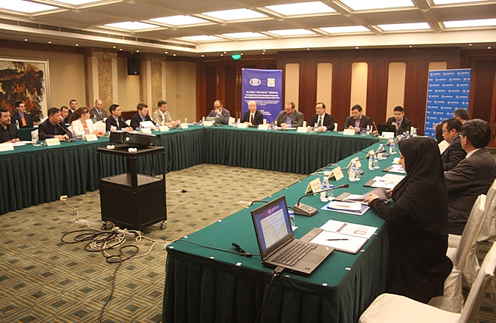

Opportunities for Cooperation:
While much of the workshop focused on diagnosing the region’s problems and conflicts, there were areas that were highlighted for cooperation amongst states.
- The Middle East offers opportunities for China and the United States to cooperate on several issues where their interests align: political solutions to hotspot issues, anti-piracy, humanitarian assistance, and infrastructural investment, among others. The main hurdle to overcome is to find a starting point, a specific project that can be used to build a cooperative framework.
- Where multilateral cooperation is improbable, there remains many opportunities for states to improve bilateral ties. Inter-regional communication remains weak, but so to do many bilateral relationships within the Middle East.
- States that have the capacity and relationships to do so should invest in intensifying cooperative engagement amongst Middle Eastern states. Examples include the United States working to enhance relations amongst its regional allies in combatting violent extremism, or greater engagement amongst the states of the Mediterranean region regarding refugees (Levant and North Africa).
- Refugees – the refugee crisis as a result of the Syrian conflict has created a tremendous strain on neighboring states. Regional states, seeking to avoid further humanitarian crisis and to mitigate the threats that can emerge from displace communities, can work together to improve the conditions of refugees and seek to create opportunity for refugees to obtain employment. Non-regional powers can further enhance such efforts and can work with a large section of the region.
- Environmental conditions are dire in some parts of the Middle East and regional and non-regional states could cooperate to address these problems. Example – if the current conflict is deescalated in the near future, there is a severe water shortage in Yemen that offers a platform for international cooperation.

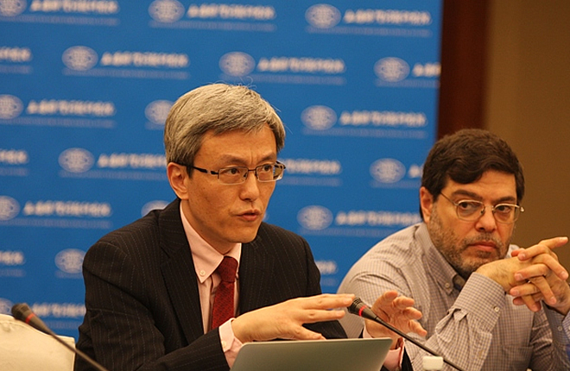

Seminar Schedule
Wednesday, 6 May – Day One

09:00 – 09:20 Opening Session
Speakers:
Dr. Yang Jiemian, Chairman of Academic Council, Shanghai Institutes forInternational Studies (SIIS)
Mr. Jeffrey Payne, Manager of Academic Affairs, Near East South Asia Center forStrategic Studies (NESA)

09:20 – 11:00 Session 1 Trends of the Strategic Crossroads
Moderator:
Dr. Murhaf Jouejati, Professor, NESA

Presentations: (10-15 minutes for each speaker)
1. Geo-economics and China’s soft military presence in the Middle East; Dr. Sun Degang, Deputy Director, Institute for Middle East Studies, ShanghaiInternational Studies University (SISU)
2. Religious Radicalism in the Middle East and its Impacts; Dr. Jennifer Jefferis, Professor, NESA
3. Foreign Terrorist Fighters and Turkey; Dr. Haldun Yalçınkaya, Professor, Center for Middle Eastern Strategic Studies (ORSAM)
4. Strategic Trends in the Region; Dr. Mohsen Shariatinia, Asia Research Group, Center for Strategic Research

Free Discussion

11:00 – 11:15 Group Photo and Coffee Break

11:15 – 12:45 Session 2 Strategic Vision and the Strategic Crossroads

Moderator:
Amb. Hua Liming,Former Chinese Ambassador to Iran

Presentations: (10-15 minutes for each speaker)
1. Reconstructing Middle East Order Is Urgent Needed: Dr. Tang Zhichao, Director, Department of Middle East Studies,Chinese Academy of Social Sciences (CASS)
2. China, Pakistan & Afghanistan - Prospects for Strategic Cooperation; Dr. Andrew Small, Transatlantic Fellow, German Marshall Fund of the United States
3. Nuclear Talks and the Rise of Extremism in the Region; Dr. Mohammad Marandi, Professor of North American Studies and Dean of theFaculty of World Studies, University of Tehran

Free Discussion

12:45 – 13:45 Lunch
Venue: Picardie Cafe, Ground Floor

13:45 – 15:15 Session 3 Strategic Issues:Conflicts within the Region

Moderator:
Dr. Ye Qing, Director, Center for West Asian and African Studies, SIIS

Presentations: (10-15 minutes for each speaker)
1. The Syrian Conflict; Dr. Murhaf Jouejati, Professor,NESA
2. The Aftermath of the Decisive Storm?;Dr. Mahjoob Zweiri, Professor, Qatar University
3. Three Historical Analogies and the Limits of US-Iran Détente; Dr. Jin Liangxiang, Research Fellow, Center for West Asian and African Studies, SIIS

Free Discussion

15:15 – 15:30 Coffee Break

15:30 – 17:00 Session 4 Strategic Issues: The Roles of Regional and External Actors

Moderator:
Dr. Jennifer Jefferis, Professor, NESA

Presentations: (10-15 minutes for each speaker)
1. Transformation of Regional Order in the Middle East and Its Implication to China; Dr. Ye Qing, Director, Center for West Asian and African Studies, SIIS
- Revisiting the “Trading State”: The Economics of Turkey's Foreign Policy in a Turbulent Middle East; Mr. Altay Atli, Asian Studies Center, Bogazici University
3.Nervous Dependency: Indian Policy towards West Asia; Mr. Pramit Pal Chaudhuri, Journalist, Hindustan Times
4. China in the Middle East: Interests and Principles; Dr.WuBingbing, Director, Institute for Arab and Islamic Studies, Peking University

Free Discussion

17:30 Welcome Dinner
Hosted by Dr. Chen Dongxiao, President of SIIS
Venue: Magnolia Room, 3rd floor, Annex, Hengshan Picardie Hotel

Thursday, 7 May – Day Two

09:00 – 09:15 Review of Previous Day

Speakers:
Dr. Ye Qing, Director,Center for West Asian and African Studies, SIIS
Mr. Jeffrey Payne, Manager of Academic Affairs, NESA

09:15 – 10:30 Session 5 Strategic Issues: Progress/Steps Forward?

Moderator:
Dr. Chen Dongxiao, President of SIIS

Presentations: (10-15 minutes for each speaker)
1. China-Middle East Economic Relations within the Context of Belt-and-Road Initiative; Dr. Wang Jian, Professor, Institute for History Studies, Shanghai Academy of Social Sciences (SASS)
2. The Trends of Iran Nuclear Issue; Ms. Parisa Shah Mohammadi, Institute for Political and International Studies (IPIS)
- India and the West Asian Region: Adapting to New Regional Realities; Dr. Meena Singh Roy, Research Fellow, Institute for Defence Studies and Analyses

Free Discussion

10:30 – 10:45 Coffee Break

10:45 – 11:55 Wrapping Up

Moderator:
Mr. Jeffrey Payne, Manager of Academic Affairs, NESA
Discussion on Policy Recommendations

11:55-12:00 Concluding Remarks
Dr. Chen Dongxiao, President of SIIS

12:00 – 13:00 Lunch
Venue: Picardie Cafe, Ground Floor

Please note that the information included in this report is a merger of ideas presented during the workshop and should not be viewed as representative of the opinions of individual participants nor the point of view of the Shanghai Institutes for International Studies or the Near East South Asia Center for Strategic Studies.

